HOK Utilities 

*(Updated 2014-09-12 by Jinsol Kim)*

## Overview

This package of utility tools has been developed based on special requests from BIM managers. The lists of tools mostly have simple functionality that measures the dimension of model elements, creates new elements and writing parameter values.

## Installation

Select the check box, Include BETA files, and select the Utility Tools and confirm the version released and installed.

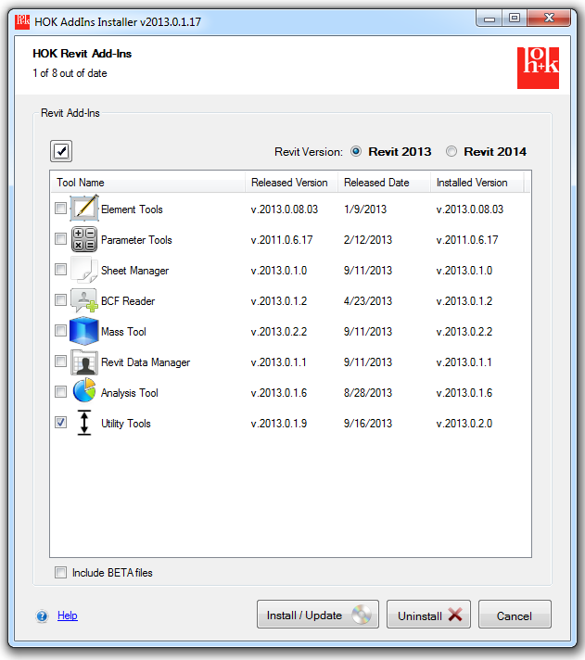

Contents

Overview 1

Installation 1

***1.*** ***Finish Creator*** 3

1.1 Creating Finishes 3

***2.*** ***Ceiling Height*** 5

2.1 Measuring Ceiling Heights 6

2.2 Creating Shared Parameters 7

***3.*** ***Level Manager*** 8

3.1 Selecting Elements 8

3.2 Maintaining Physical Location 10

3.3 Deleting Levels after Re-hosting 12

3.4 Copying Rooms (2014 Only) 12

***4.*** ***View Depth*** 14

***5.*** ***Leader Arrowhead*** 17

***6.*** ***View Creator*** 18

***7.*** ***Door Link*** 20

7.1 Copying Revit Internal Room Data 21

7.2 Retrieving Rooms from Linked Models 22

***8.*** ***Room Updater*** 24

# ***Finish Creator***



To represent finishes as an element, this tool will create a thin floor with default thickness ¼” based on boundary lines of selected rooms, and place the new floor on top of the actual floor element the room bounded by.

## Creating Finishes

* Find the Finish Creator command button in HOK Utilities panel under the Add-ins tab, and click the button
* It will notify you to start selecting rooms. After the completion of the selection, click Finish on the options bar on left-top corner.

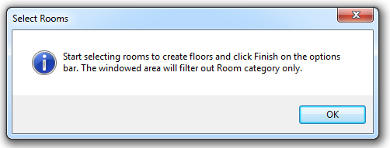

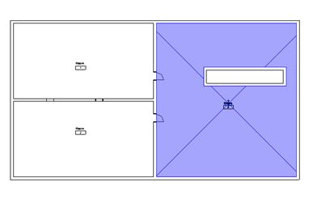

* You will be able to find the new floor elements created on top of the existing floor element. The base lines of each finish floor will be created based on the boundary lines of each room and the bottom surface will be extruded up to ¼” as default.

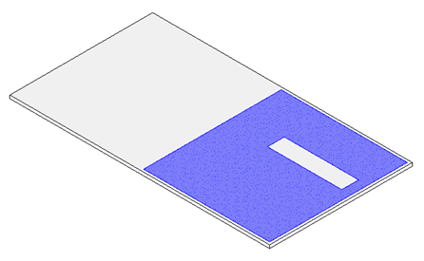

# ***Ceiling Height***



This tool will calculate the ceiling height by measuring distance from the base elevation of rooms to the elevation of ceiling.

Note: Level parameter of a ceiling should be set as same as Level parameter of a room to be regarded as the ceiling is pertained to the room.

If level values are same between a room and a ceiling, it will calculate the ceiling height like the followings. The actual room height is not important.

***Ceiling Height (room parameter)***

***= Height offset From Level (ceiling parameter) - Base Offset (room parameter)***

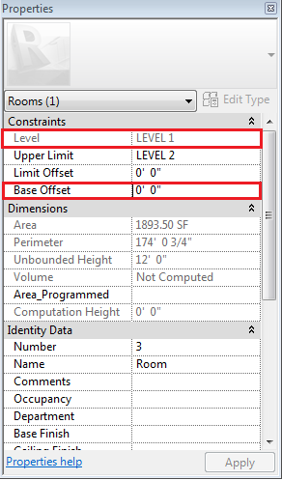

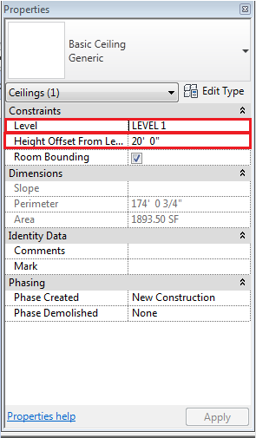

Ceiling Height: 20’ = Height Offset From Level: 20’ – Base Offset: 0’

## Measuring Ceiling Heights

* Find the Ceiling Height command button in HOK Utilities panel under the Add-Ins tab, and click the button
* It will notify you to start selecting rooms. After the completion of the selection, click Finish on the options bar on left-top corner.

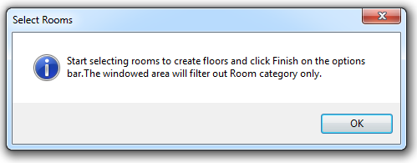

The tool will find appropriate ceilings following rules below.

1. If ceilings exist and intersect with a virtual solid created by room boundary lines with its height defined in room constraints, the ceilings will be mapped to the corresponding room.
2. If no ceiling is enclosed by the room solid, the tool will recursively create temporary bounding boxes to see if there are some intersecting ceilings with the bounding box. If any ceilings are found, they will be returned.
3. When multiple ceilings are found on top of the room following those two methods, this tool will determine a major ceiling that has the largest overlapping area among other ceiling elements.

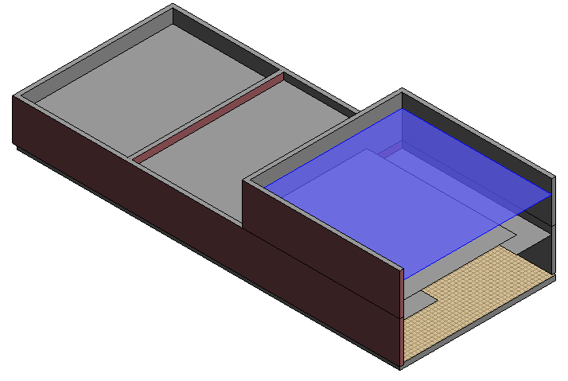

## Creating Shared Parameters

After measuring the ceiling height, this tool will create shared parameters and write the information in room elements.

1. **Ceiling Heights**: the height of the largest ceiling
2. **Secondary Ceiling Heights**: lists of ceiling heights existing on the room *(this will not include the major ceiling height - updated v.2013.0.1.5)*
3. **Ceiling Plan**: the name of ceiling plan in which the largest ceiling exists.
4. **Ceiling Materials**: lists of the name of ceiling materials obtained from the type mark of the ceiling type

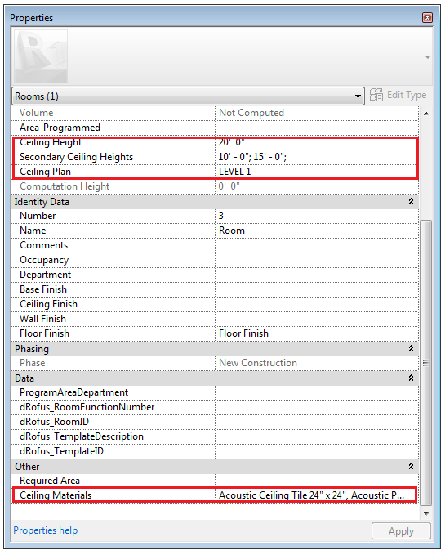

# ***Level Manager***



This tool will allow for elements to be re-hosted by another level, so that a duplicated level can be eliminated. The deprecated level elements can be deleted only if all elements are successfully migrated to the new level. Otherwise, the tool will navigate through not movable elements in the background with highlighted.

The Level Manager will work with Family Instances which has Level parameter and System Families with following parameters.

|  |  |
| --- | --- |
| Revit Categories | Parameters Associated |
| Building Pads | Level, (Height Offset from Level) |
| Cable Tray | Reference Level, (Offset) |
| Ceilings | Level, (Height Offset from Level) |
| Columns | Base Level, (Base Offset, Top Level, Top Offset) |
| Conduit | Reference Level, (Offset) |
| Duct | Reference Level, (Offset) |
| Flex Duct | Reference Level, (Offset) |
| Floors | Level, (Height Offset from Level) |
| Model Groups | Reference Level, (Origin Level Offset) |
| Pipe | Reference Level, (Offset) |
| Roofs | Base Level, (Offset) |
| Rooms** | Level |
| Shaft Openings | Base Constraint (Base Offset, Top Constraint, Unconnected Height) |
| Stairs | Base Level, (Base Offset, Top Level, Top Offset) |
| Walls | Base Constraint, (Base Offset, Top Constraint, Unconnected Height) |

**The option for copying and pasting rooms is only available in Revit 2014

## Selecting Elements

There are three options to make a group for elements to be re-hosted to a new level.

1. All Elements: It will collect all elements hosted by the level assigned in Element Migration From, and re-host to a new level in Element Migration To.
2. Selected Elements: It will make the Element Migration From option disabled, and re-host all selected elements to a new level assigned in Element Migration To.
3. Selected Categories: elements can be filtered out by selected categories , and re-host them to the new level.

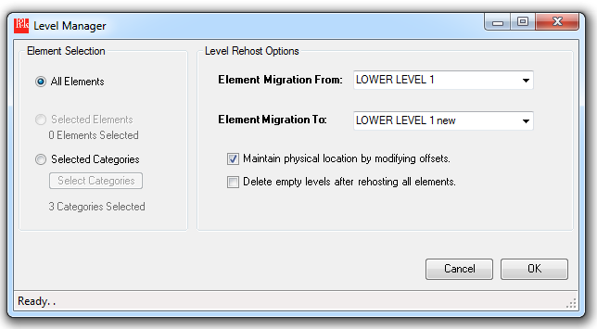

Only categories that have Level parameter which is not read-only will be listed in the category option window.

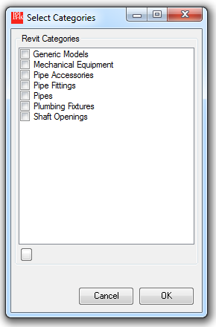

## Maintaining Physical Location

1. When the check box, Maintain physical location by modifying offsets, is not selected, the elements will be simply relocated from one level to another with a same base offset value as the original element has.

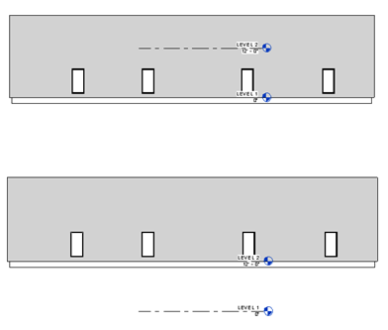

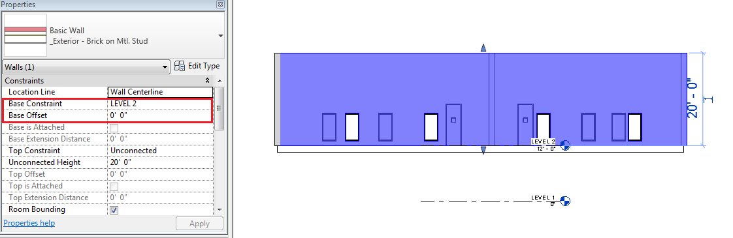

1. When the check box, Maintain physical location by modifying offsets, is selected, all level parameters of elements will be set to a new level, but their physical location will be remain same by adjusting their offset values.

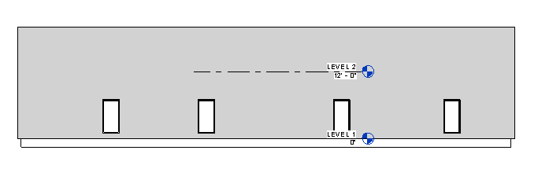

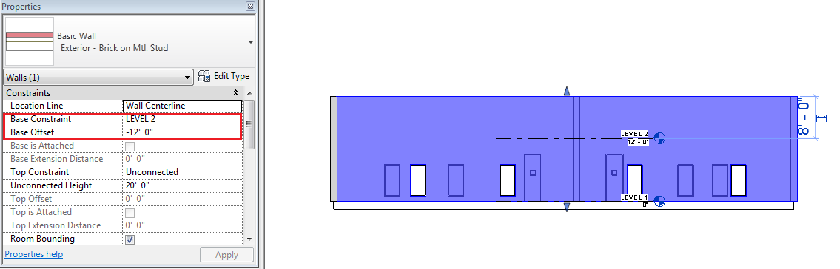

## Deleting Levels after Re-hosting

If the checkbox, Delete empty levels after re-hosting all elements, is selected, this tool will delete the level element after the migration of all elements. If this process is failed, this error message will be prompted showing the failed elements with highlighted in Revit background.

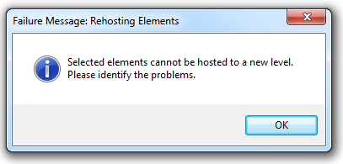

## Copying Rooms (2014 Only)

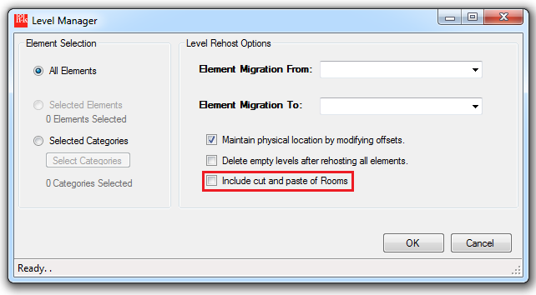

If room elements exist in the collected elements to proceed, by selecting the option, Include cut and paste of Rooms, the tool will copy and paste rooms into the new migrating level. At the event, if rooms are bounded by room separation lines, the tool will also copy and paste them at the equivalent XY coordinates on the new level without any translation. If rooms and room separation lines are successfully copied, all the original rooms will be deleted.

One limitation of this functionality is that it won’t copy room tags, which are view specific elements.

# ***View Depth***



The View Depth tool will override graphics in a view by elements adjusting the color of project lines based on the distance of elements from the view point. This tool will measure the depth of each element and classify them into three groups by distance so that the color of project lines will be applied like following.

*Element Group 1* – the most adjacent: will preserve the original color of the project lines.

*Element Group 2* – located in the middle: will change to a new color as R-128, G-128, B-128

*Element Group 3* – the most distant: will change to a new color as R-192, G-192, B-192

The limitation of this tool is not to support for views created from linked files and any types of 3D views.

It is recommended to create a section view to be covered with groups of elements placed in a variety of view depth.

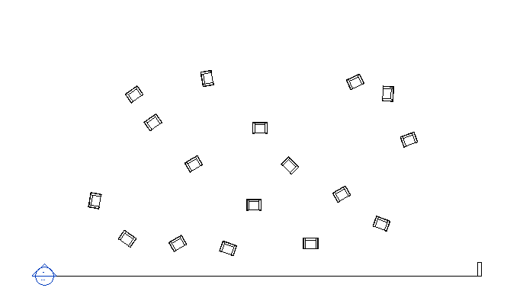

The section view below is represented with pre-defined colors of project lines varying depending on the object style.

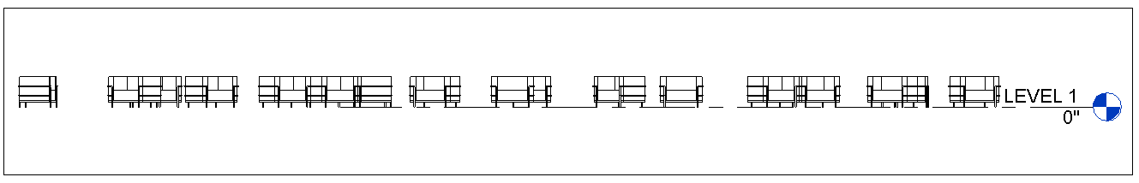

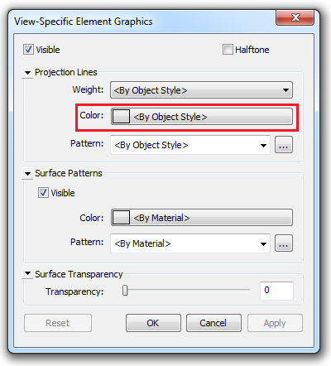

After running the command of View Depth, different colors of project lines will be applied, if certain elements are placed in a range of middle distance of area or much further from the view point.

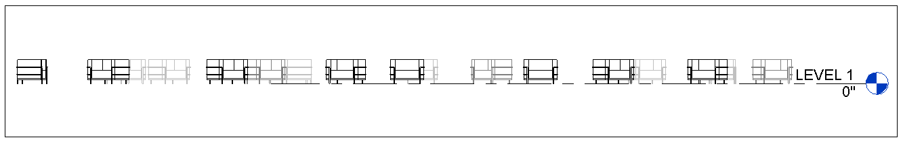

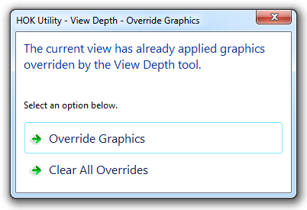

In order to reinstate a view from the graphics overrides applied by the View Depth tool, you can simply execute the tool in the same view and select an option, “Clear All Overrides” in the task dialog box.

# ***Leader Arrowhead***



The Leader Arrowhead tool will assign a specific arrowhead style to all family types by switching the value of the parameter named Leader Arrowhead to the chosen style.

In the HOK Utilities pane, find the command button for the Leader Arrowhead among the list of buttons.

The main command window will be shown with the option to select one of arrowhead styles.

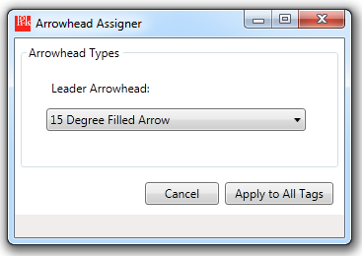

Select one of styles and click the button, Apply to All Tags. At the end of the process, you will be able to see the completion message like below.

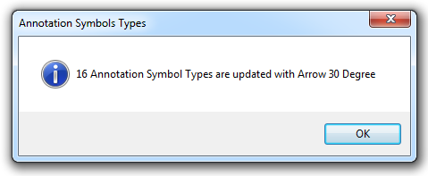

# ***View Creator***



The View Creator tool will create new 3d views or plan views or update already created views based on the information of the chosen items among Worksets, Phases or Design Options.

Go to the HOK Utilities panel and select the View Creator button and then you will see the main window.

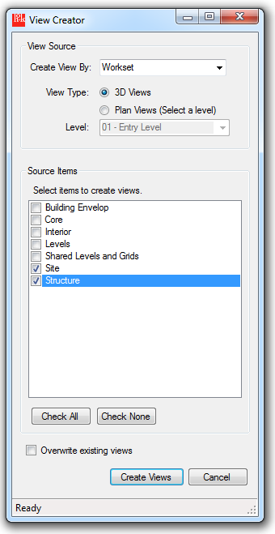

Select one of options among Worksets, Phases and Design Options from “Create View By”, and then select either 3D Views or Plan Views. The selection of Level will be required when creating plan views.

Make a selection of source items in the checked list box for the views to be created.

If the option, , is selected, the existing views will be updated with the pre-defined settings of this tool.

You will be able to end up seeing the completion message like below.

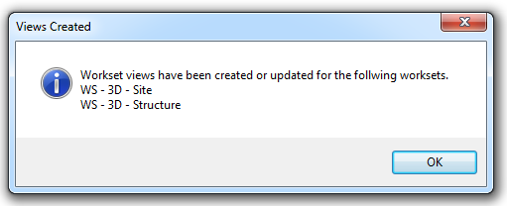

The name of views will be created with the following prefix and suffix.

|  |  |  |
| --- | --- | --- |
|  | **3D Views** | **Plan Views** |
| **Worksets** | WS – 3D – [*Workset Name*] | [*Level Name*] – [*Workset Name*] |
| **Phases** | PH – 3D – [*Phase Name*] | [*Level Name*] – [*Phase Name]* |
| **Design Options** | OP – 3D – [*Option Name*] | [*Level Name*] – [*Option Name*] |

***Workset Views***: visibility settings that controls the display of worksets will be applied to the creating views. Only the source workset will be visible in the created view.

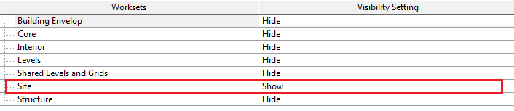

***Phase Views***: the phase of the view will be set to the one chosen by the tool.

***Design Options Views***: the tool will simply create views with the name of design options.

# ***Door Link***



The Door Link command will define the two pair of adjacent rooms, From-Room and To-Room, to door elements by the geometric location of the rooms and doors. If the command finds corresponding rooms, the information of room will be written in door parameters.

***Requirement – Shared parameters***

Before running the Door Link command, the following four shared parameters in the message box shown below should be prepared under the Door category.

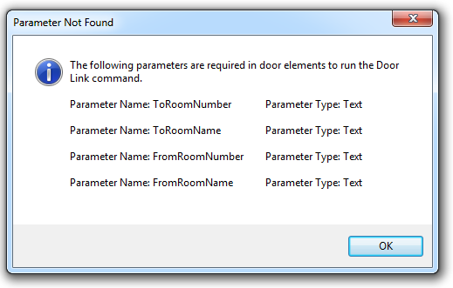

## 7.1 Copying Revit Internal Room Data

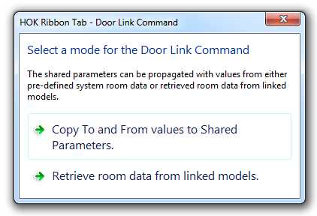

Select the first option, “Copy To and From values to Shared Parameters.”

This command options will gather the information of all door instances and determine whether the ToRoom and FromRoom values from Revit internal data has been set correctly. For example, sometimes when a door is facing flipped, the internal parameters of ToRoom and FromRoom are not updated based upon the changes. Once the ToRoom and FromRoom are verified, the information will be written in shared parameters. You will get a completion message if all values are successfully written in shared parameters of door elements.

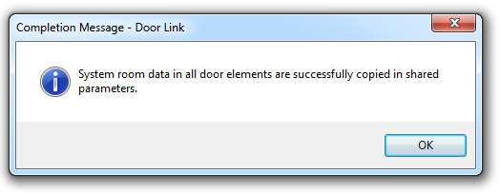

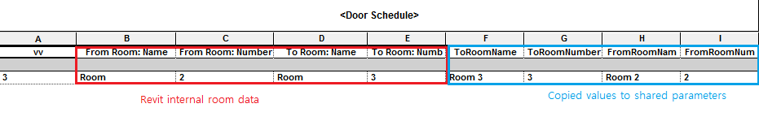

## 7.2 Retrieving Rooms from Linked Models



Select the second option, “Retrieve room data from linked models.”

When room elements exists in linked models and doors in the host model, this tool will iterate all door elements to retrieve corresponding To-Room and From-Room based upon the geometric adjacency. *(Note: door elements from linked models will NOT be regarded as the input of this tool)*

In order to find To-Room and From-Room, this tool will create two virtual offset points along the direction of the door facing. If To-Point lies in the volume of a room, the room will be defined as To-Room, and the same method will be applied to From-Room.

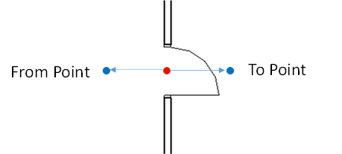

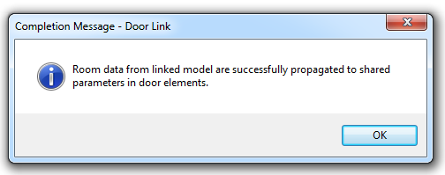

After the completion message, you will be able to find the shared parameters updated either door properties or door schedules.

As you can see the door schedule below, Revit cannot define the relationship between doors and their adjacent rooms, when the room elements reside in liked models. All the adjacent rooms will be programmatically defined and set those values in shared parameters by the Door Link command.

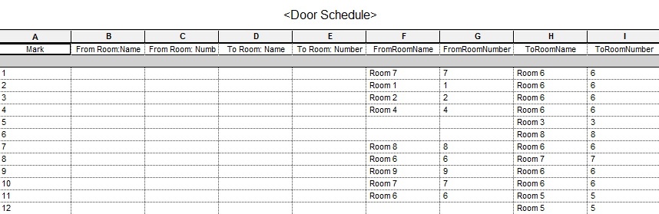

# ***Room Updater***



The Room Updater will capture parameter values from spatial elements and populate the values to elements enclosed by each solid of the spatial elements.

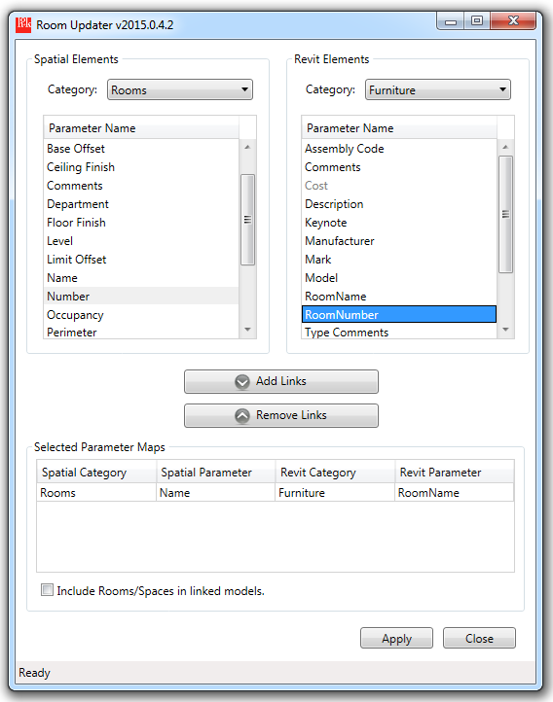

In order to create parameter maps,

* **Spatial Elements Category:**

Select a category from the pull-down menu of Spatial Elements Category.

It only has two options, either Rooms or Spaces

* **Revit Elements Category:**

Select a category from the pull-down menu of Revit Elements Category.

Only model categories existing in the Revit project will become options in the menu.

* **Spatial Elements Parameter:**

Select a parameter of spatial elements in the list.

Only built-in parameters and project parameters of the selected category will be displayed in the list.

* **Revit Elements Parameter:**

Select a parameter of Revit elements in the list.

Note: by selecting an item among the spatial elements parameter, the color of items in the Revit elements list will be differentiated based on the storage type of the selected parameter.

e.g. If the string type of parameter, “Name”, is selected in Spatial Elements, parameters which have different storage types such as integer, ElemenId will be grayed out in the Revit Elements list.

*black text: selectable parameter

*gray text: not selectable (storage type does not match)

Click “Add Links” button and “Apply” button to populate parameter values.

**Remove Links**: You can also select a parameter map from the Selected Parameter Maps, and click “Remove Links” button to disable the parameter map for the Room Updater.

**Settings**: When you revisit the UI after executing the command, you will notice that user defined settings in the previous run are stored and displayed in the UI.

**Model Groups**: If some of elements belong to model groups, the Room Updater will skip those elements. Parameters in model groups cannot be editable, unless ungrouping the groups to each individual elements.